Strengthening the Foundation for
Meaningful Family Engagement

General Resources
- ECAC FACT Sheet (English / Spanish)
- Family to Family (F2F) Health Information Center (English /Spanish)

For Families
- Painting the Big Picture, is a tool to share information about your child with service providers and teachers. (English/Spanish)
- IEP checklist (English/Spanish)
- Sharing What You Know with Professionals (English/Spanish)
- Participating on Your Child’s Team (English/Spanish)
- Working Together to Support Children’s Learning and Development (English/Spanish)
- NC Medicaid Waivers for People with Disabilities
Engaging Families
- Family Capacity Building in Early Childhood Intervention
- Why Family Engagement Matters for Student and School Success
- Engaging ELL Families: Twenty Strategies for School Leaders
- Family Engagement Core Competencies
- Questions for Building Trust
- Core Beliefs and Key Strategies
- Communicating with Families Around Academics
- Beginning of Year Relationship Building
- A Guide to Local Special Education Parent Advisory Councils

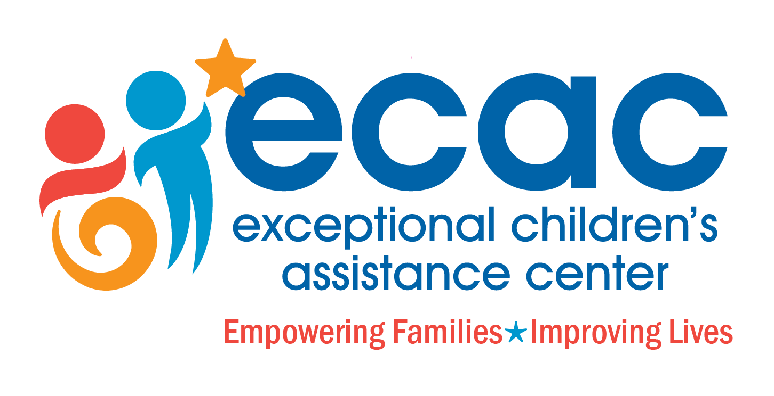
1-800-962-6817
www.ecac-parentcenter.org

